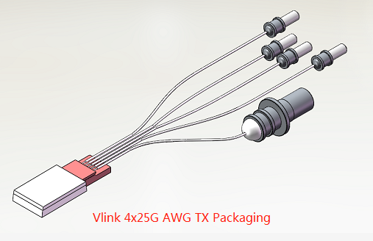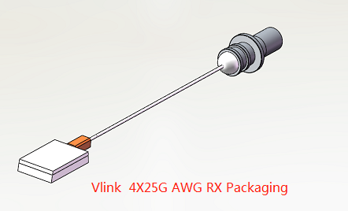Vlink 高速AWG光器件封装

AWG的封装过程包括耦合对准和粘接等操作。AWG芯片与光纤阵列的耦合对准有手工和自动两种，它们依赖的硬件主要有六维精密微调架、光源、功率计、显微观测系统等，而最常用的是自动对准，它是通过光功率反馈形成闭环控制，因而对接精度和对接的耦合效率高。

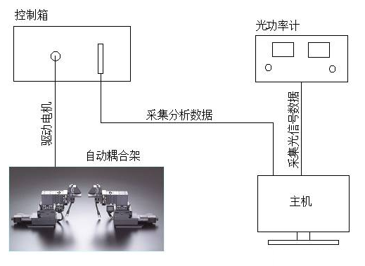

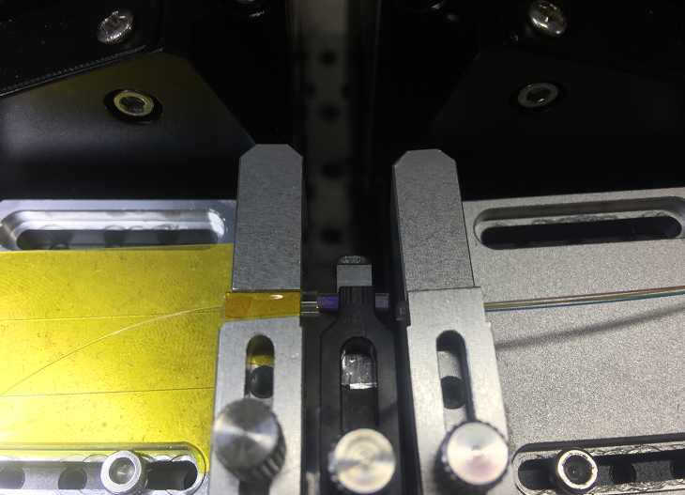  
　　AWG封装主要流程如下：

　　（1）耦合对准的准备工作：先将波导清洗干净后小心地安装到波导架上；再将光纤清洗干净，一端安装在入射端的精密调整架上，另一端接上光源（先接6.328微米的红光光源，以便初步调试通光时观察所用）。

（2）借助显微观测系统观察入射端光纤与波导的位置，并通过计算机指令手动调整光纤与波导的平行度和端面间隔。组件装夹完成后，有必要通过校正X,Y和Z方向的偏差来进行的初始光功率耦合。

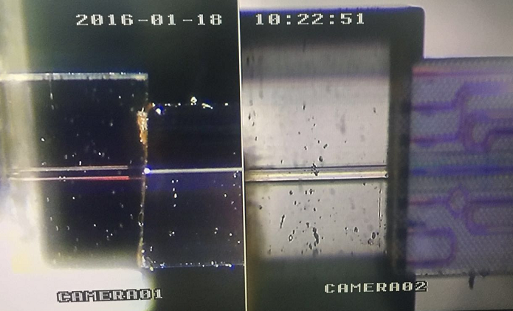

　　（3）打开激光光源，根据显微系统观测到的X轴和Y轴的图像，并借助波导输出端的光斑初步判断入射端光纤与波导的耦合对准情况，以实现光纤和波导对接时良好的通光效果。

　　（4）当显微观测系统观察到波导输出端的光斑达到理想的效果后，移开显微观测系统。

　　（5）将波导输出端光纤阵列（FA）的第一和第四通道清洗干净，并用吹气球吹干。再采用步骤(2)的方法将波导输出端与光纤阵列连接并初步调整到合适的位置。然后将其连接到双通道功率计的两个探测接口上。

（6）将光纤阵列入射端6.328微米波长的光源切换为1270/1330微米的光源，启动光功率搜索程序自动调整波导输出端与光纤阵列的位置，使波导出射端接收到的光功率值最大，且两个采样通道的光功率值应尽量相等（即自动调整输出端光纤阵列，使其与波导入射端实现精确的对准，从而提高整体的耦合效率）。

（7）当波导输出端光纤阵列的光功率值达到最大且尽量相等后，再进行点胶工作（以TOSA为例）。

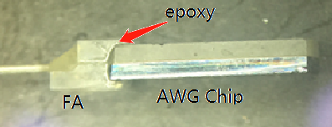

　　（8）重复步骤（6），再次寻找波导输出端光纤阵列接收到的光功率最大值，以保证点胶后波导与光纤阵列的最佳耦合对准，并将点胶和固化，再进行后续操作，完成封装。

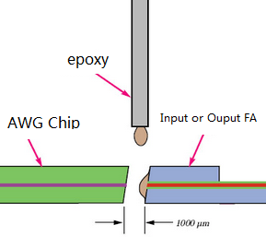

　　在上面的耦合对准过程中，AWG芯片有4个通道且每个通道都要精确对准，由于波导芯片和光纤阵列（FA）的制造工艺保证了各个通道间的相对位置，所以只需把AWG与FA的第一通道和第四通道同时对准，便可保证其他通道也实现了对准，这样可以减少封装的复杂程度。在上面的封装操作中最重要、技术难度最高的就是耦合对准操作，它包括初调和精确对准两个步骤。其中初调的目的是使波导能够良好的通光；精确对准的目的是完成最佳光功率耦合点的精确定位，它是靠搜索光功率最大值的程序来实现的。对接光波导需要6个自由度；3个平动（X、Y、Z）和3个转动（α、β、g），要使封装的波导器件性能良好，则对准的平动精度应控制在0.5微米以下，转动精度应高于0.05度。

AWG的封装：

　　对AWG进行封装，封装的耦合对准过程采用上面介绍的封装工艺流程。对准封装后的结构如图3所示，封装的组件由AWG芯片和光纤阵列组成。在AWG芯片的连接部位，为了确保连接的机械强度和长期可靠性，对玻璃板整片用胶粘住。光纤阵列是用机械的方法在玻璃板上以250微米间距加工成V形沟槽，然后将光纤阵列固定在此。制作4芯光纤阵列的最高累计间隔误差平均为0.48微米，精确度极高。在AGW芯片与光纤阵列的连接以及各个部件的组装过程中，为了减少组装时间，采用紫外固化粘接剂。光纤连接界面是保持长期可靠的重点，应选用耐湿、耐剥离的氟化物环氧树脂与硅烷链材料组合的粘接剂。为了减少端面的反射，采用8°研磨技术。

**关于深圳加华微捷 VLINK Optics Corproation**

深圳加华微捷Vlink是一家研究开发、生产、销售硅光子连接产品和微光学连接产品的高科技公司，主要产品包括SR4/PSM跳线，硅光子互连结,CWDM4/LAN WDM模块，PLC CWDM/LAN WDM模块，主要应用于40G、100G、400G等高速、超高速光模块中。未来加华微捷Vlink将整合更多资源，力争成为全球高速光学连接产品创新探索者，为客户提供更精微尺寸、更低能耗、更低成本的高速光学光纤互连方案。

Vlink High Speed AWG Optical Device Package



AWG packaging process includes coupling alignment and bonding operations. The coupling of the AWG chip to the fiber array is manual and automatic. The mainly hardware they rely on is: six-dimensional precision trimming frame, light source, power meter, microscopic observation system, etc. The most commonly used is automatic alignment, which forms closed-loop control through optical power feedback, so the coupling accuracy and docking coupling efficiency are high.





The main process of AWG packaging is as follows:

1. Preparation for coupling alignment, clean the waveguide and carefully install it on the waveguide; then clean the fiber again, one end is mounted on the precision adjustment frame on the incident end, and the other end is connected to the light source(first connect the 6.328 micron red light source for the initial debugging of the light).
2. Observe the position of the fiber at the incident end and the waveguide by means of a microscopic observation system, and manually adjust the parallelism and end face spacing of the fiber and the waveguide by computer instruction. After assembly of the component is completed, it is necessary to perform initial optical power coupling by correcting the deviations in the X, Y, and Z directions.
3. Turn on the laser light source, according to the images of the X-axis and the Y-axis observed by the microscopic system, and by means of the spot at the output end of the waveguide, the coupling alignment of the fiber at the incident end with the waveguide is preliminarily determined to achieve a good light-passing effect when the fiber and the waveguide are docked.
4. When the microscopic observation system observes that the spot at the output of the waveguide has achieved the desired effect, the microscopic observation system is removed.
5. The first and fourth passages of the waveguide output fiber array (FA) are cleaned and blown dry with a balloon. Then, the waveguide output end is connected to the fiber array by the method of the step (2) and is initially adjusted to a suitable position. It is then connected to the two probe interfaces of the dual channel power meter.
6. The light source of 6.328 micron wavelength at the incident end of the fiber array is switched to a light source of 1270/1330 micrometer, and the starting optical power search program automatically adjusts the position of the waveguide output end and the fiber array, so that the optical power received by the wave deriving end is the largest, and two The optical power values of the sampling channels should be as equal as possible (ie, the output fiber array is automatically adjusted to achieve precise alignment with the waveguide entrance end, thereby improving overall coupling efficiency).
7. When the optical power value of the fiber array at the output of the waveguide reaches the maximum and is equal, the dispensing operation is performed (for example, TOSA).



1. Repeat step (6) to find the maximum optical power received by the fiber array at the output of the waveguide to ensure optimal coupling alignment between the waveguide and the fiber array after dispensing, and then dispense and solidify, and then perform subsequent operations to complete Package.



In the above coupling alignment process, the AWG chip has 4 channels and each channel is precisely aligned. Since the manufacturing process of the waveguide chip and the fiber array (FA) ensures the relative position between the channels, it is only necessary to Simultaneous alignment of the AWG and FA with the first and fourth channels ensures that other channels are also aligned, which reduces package complexity. The most important and technically difficult part of the above packaging operation is the coupling alignment operation, which includes two steps of initial adjustment and precise alignment. The purpose of the initial adjustment is to enable the waveguide to pass light well; the purpose of precise alignment is to achieve accurate positioning of the optimal optical power coupling point, which is realized by a program for searching the maximum value of optical power. The docking optical waveguide requires 6 degrees of freedom; 3 translations (X, Y, Z) and 3 rotations (α, β, g). To make the packaged waveguide device perform well, the alignment translation accuracy should be controlled. Below 0.5 microns, the rotation accuracy should be higher than 0.05 degrees

AWG package

The package alignment process uses the package process described above. The structure after alignment is shown in Figure 3. The package components are composed of AWG chip and fiber array. In order to ensure the mechanical strength and long-term reliability of the connection at the joint of the AWG chip, the entire glass sheet is glued. The fiber array is mechanically machined into a V-shaped groove at a pitch of 250 microns on a glass plate, and then the fiber array is fixed here. The highest cumulative spacing error for a 4-core fiber array is 0.48 microns, which is extremely accurate. In order to reduce the assembly time during the connection of the AGW chip to the fiber array and the assembly of the various components, an ultraviolet curing adhesive is used. The fiber optic connection interface is the key to maintaining long-term reliability. Adhesives that combine moisture and epoxy resistant epoxy resins with silane chain materials should be used. In order to reduce the reflection of the end faces, an 8° grinding technique is employed.

**About VLINK Optics Corporation**

VLINK Optics is a high technology company focusing on developing, manufacturing and selling silicon photonics fiber connectivity and micro/short fiber jumper used on 40G, 100G and 400G high speed transceiver modules, including

* SR4 MT-MT jumper,
* PSM4 MT-FA jumper,
* MT-FA for grating coupling or edge coupling of silicon photonics package,
* TFF CWDM4/LAN WDM or PLC CWDM4/LAN WDM subassembly
* High PER Polarization-Maintaining devices

VLINK keep integrating advanced technologies and resources, trying to be an innovator and explorer on the field of fiber optics micro connection on high speed modules. VLINK provide customer fiber optics micro-connection solutions of inter-connecting in high speed modules with compact size, low power consumption, cost effective and quality guarantee.